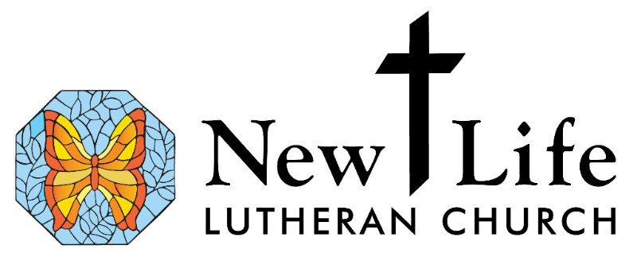
Youth Education

Registration Form

Child’s Name___________________________ Grade______

Address___________________________________

City & Zip _______________________________________

Home Phone __________________________________________

Date of birth__________

Parent(s) name______________________________

Parent e-mail ________________________________

Parent cell phone _____________________________

How do you prefer to receive communication about youth education?
____ Email ____ Text msg ____ Mail ____ Website
____ Narthex posting ____ Facebook Other__________________

Food allergies/Special educational concerns:

Parental involvement in Youth Education at New Life...
Would you be willing to serve as a:

___Substitute teacher ___ Coordinate a fellowship event
____ Photographer ____ Other

Medical Release
I grant permission for youth leaders to take whatever steps necessary to obtain emergency medical care for the well-being of my child. My signature below indicates that any expenses incurred in necessary or other medical treatment are my responsibility. I will not hold any leader or organization liable for any injury or accident.

Signed ___________________________________________ Date _____________

Media Waiver and Release
If you do not return this form, it will be assumed that you give permission for your child’s image to be included in any form of communication.
I consent to my child/children being photographed, interviewed, and/or videotaped by representatives of New Life Lutheran Church and/or media outlets (newspaper, T.V., etc.). New Life uses photos of children in congregational publications to share information about New Life. Any images obtained may be reproduced by New Life and/or the public media for use in advertising, publicity, or educational activities. New Life publications include but are not limited to: the website, bulletin, annual reports, posters, banners, bulletin boards, newsletter, and other public relations materials.
I hereby waive any claims I may have, and release New Life Lutheran and its employees from liability of claims arising out of such activities.
_____ Yes, my child may be photographed, interviewed, and/or videotaped/recorded for media use
____ No, my child may not be photographed, interviewed, and/or videotaped/recorded for media use.

Verification
I verify that the information provided on this form is accurate and current, and that I am the parent/guardian of this child/these children.

Signature of Parent/Guardian ___________________________________________

Print Name of Parent Guardian __________________________________________

